NYSSLS Daily Lesson Plan
Instructional Unit:  Weather and Climate  Air masses, Fronts and Weather  LESSON: Weather reporting and forecasting |  |  |  |  |  | Period(s) of Unit:  6 Periods |  | Date:
Materials/Resources/Links: |  |  |  |  |  |  |  | Course:  Earth And Space Science
Special Notes for Lesson:

ANCHORING PHENOMINON: How do meteorologists forecast the weather.

Standards:
Science and Engineering Practices  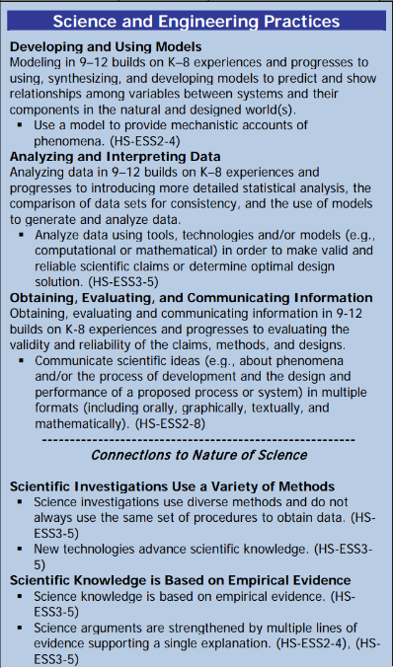 |  |  | Disciplinary Core Idea(s)  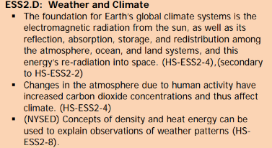 |  |  |  | Cross Cutting Concepts  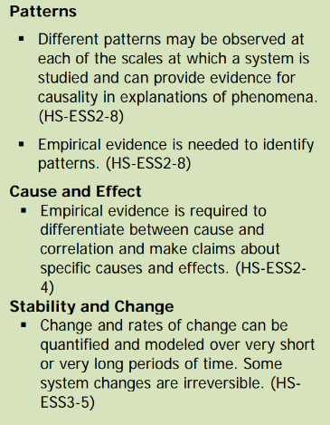
Performance Level
NYS Level 5 | NYS Level 4 |  |  | NYS Level 3 | NYS Level 2 |  |  | NYS Level 1
Collect and analyze global and regional weather data using tools, technologies, and /or models to communicate in multiple formats how the movement and interactions of airmasses result in changes in weather conditions. | Evaluate data and communicate information to explain how the movement and interactions of air masses result in changes in weather conditions |  |  | Evaluate data and communicate information to identify patterns of movement and/or the resulting changes in weather conditions. | Use data to identify the patterns of movement or the interactions of air masses and the resulting change in weather conditions  or to identify factors that drive the movement of air masses or from given weather conditions, identify evidence from maps that support these conditions. |  |  | Use data and/or patterns of movement and interactions of air masses to identify the resulting changes in weather conditions or identify one factor that drives the movement of air masses or from those provided, use evidence from maps to account for weather conditions or given weather conditions, identify evidence found on maps that account for one of these conditions.
Clarification Statement  Examples of evidence sources could include station models, surface weather maps, satellite images, radar and accepted forecast models. Emphasis should focus on communicating how the uneven heating of the Earth’s surface at frontal boundaries and resulting weather phenomena. |  |  |  |  | Assessment Boundary  Analysis is limited to surface weather maps and general weather patterns associated with High and Low pressure systems
Connection to Anchoring Phenomenon:

Using Weather maps are essential to practice weather forecasting skills.

Essential Question(s):

Instructional Strategies & Learning Tasks: Engage, Explore, Explain, Elaborate, Evaluate
Engage: images, video clip or data… |  | Students will be asked to recall the beginning of the unit where they watched weather reports/forecasts, collected weather data and checked the accuracy of the weather forecasts against collected data
Explore: Students investigate, experiment, hands-on activity…. |  | Students will be given weather data and a weather station model template. They will be told that all the weather data has a given spot on the station (which is a circle). The first task will be to place the weather data on the station model correctly. The teacher will go over the station model with the students and explain how winds and cloud cover would appear on the station model.  The students will then be given the makings of a superstorm laboratory investigation where the will have to make predictions on the movement of fronts, high and low pressure systems, and a hurricane.
Explain: Students share their observations and evidence to explain their understanding…possible whole group/class discussion… |  | Student lab groups will be asked to elaborate where they think the fronts and hurricanes will move and give a 5 day forecast for new York.
Elaborate: Students apply the science concepts they’ve just learned… |  | Students will apply the weather concepts learned throughout the unit to complete this lab
Evaluate (Formative Assessment): Student learning is evaluated. |  | Students will be evaluated bases on their forecast, teacher questions, quizzes and tests.

Copy and paste student worksheets below:
